PERFORMANCE PLOTS

* The performance of our protocol is plotted at various network scenarios simulated by the NETEM tool.
* As the protocol is a stop and wait protocol the throughput decreases proportionally.

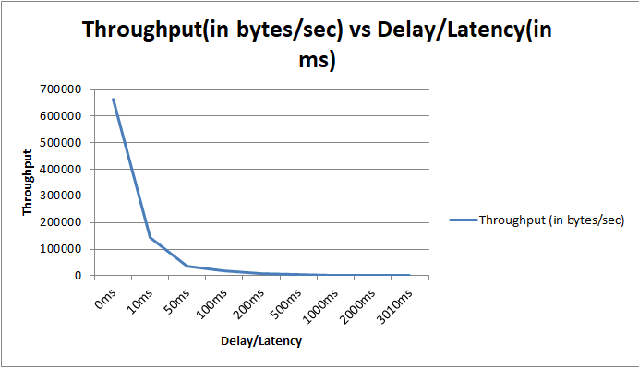

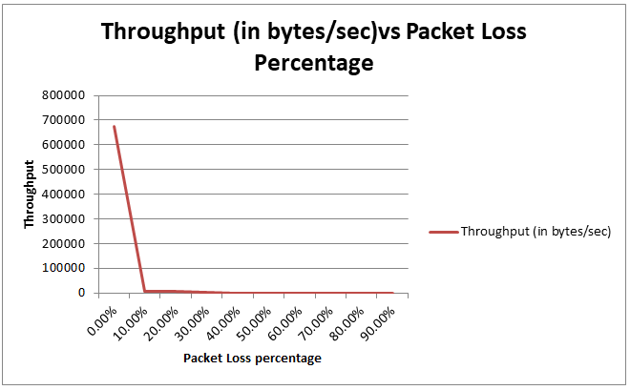

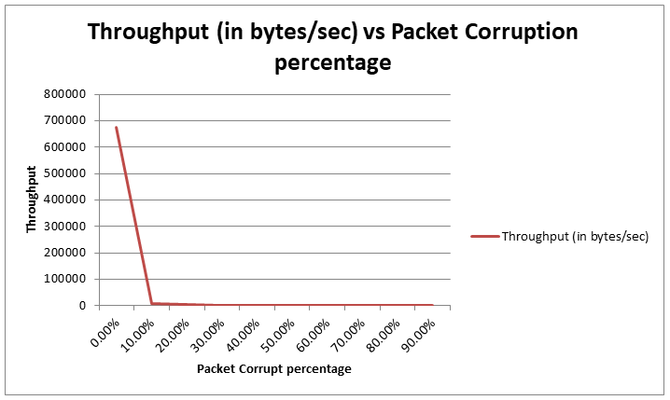

The plots of throughput vs packet corruption and packet loss are similar as the udp automatically drops corrupted packets